Introduction
In programming, you often need to store a list of related items—like filenames, user IDs, or server names. Instead of creating a separate variable for each item (e.g., file1, file2, file3), you can use a single variable called an Array.
An array allows you to store multiple values under one name. You can think of it as a list where you can add, remove, and read items.
Arrays become useful as soon as one variable is no longer enough. Server lists, filenames, package names, and user accounts are all examples of data that naturally comes in groups rather than one value at a time.
In this lab, you will learn how to:
- Declare an array with an initial set of values.
- Append new items to the array.
- Print all elements in the array.
- Iterate (loop) through the array to process each item individually.
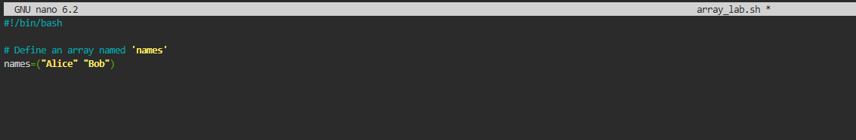
Add an Element to the Array
Often, you won't know all the items in your list when you start. You may need to add items dynamically as your script runs.
This is common in real scripts. You might build an array of matching files, active hosts, failed services, or package names discovered during execution.
We can add (append) a new item to the end of an array using the += operator.
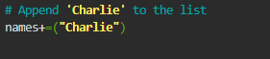
Print All Elements
To verify that our array contains everything we expect, we can print all its elements at once.
In Bash, accessing an array variable is slightly different from a normal variable. You use ${array_name[@]} to expand all elements.
@ is a special symbol acting as a wildcard for "all elements".
The ${...} form is another example of parameter expansion. Bash is not just printing the variable name literally; it is expanding the array into its stored elements before echo sees the final text.

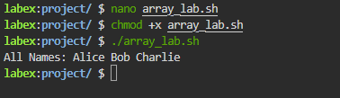
Iterate Through the Array
Printing the whole list is useful for debugging, but usually, you want to process each item individually. For example, you might want to create a user account for each name in the list.
To do this, we use a for loop
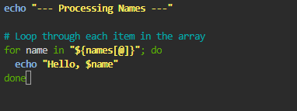
Expected output:
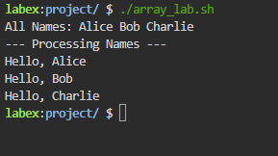
Summary
In this lab, you have learned the fundamentals of using arrays in Bash:

Declaration (name=(...)): Creating a list with initial values.
Appending (+=): Adding new items to an existing array dynamically.
Expansion (${name[@]}): Retrieving all items in the array.
Iteration (for): Processing each item in the list one by one.
Arrays are essential for writing scripts that need to handle multiple files, users, or data points efficiently.

Practice :
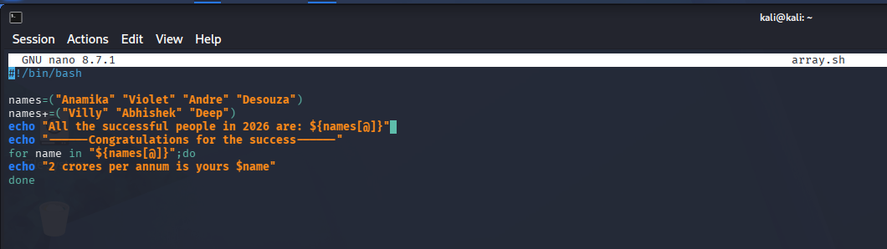
Expected output:


